DOWNTON BAPTIST CHURCH HOLIDAY CLUB 2023
www.downtonbaptist.org | 01725 512971
Dates of attendance to Holiday Club |  | Wed  26th July |  |  |  | Yes ☐  No ☐ | Thur  27th July |  |  | Yes ☐  No ☐ |  | Fri  28th July |  |  |  | Yes ☐  No ☐
Personal Data
Name of child (one per form) |  | Click or tap here to enter text.
Date of birth |  | Click or tap here to enter text. |  |  |  |  |  |  | School Year just finished  Choose an item.
Name of Parent |  | Click or tap here to enter text.
Name of person to collect child (if different) |  | Click or tap here to enter text.
Address |  | Click or tap here to enter text.
Telephone number (s) |  | Home | Click or tap here to enter text. |  |  |  |  |  |  |  | Mobile |  | Click or tap here to enter text.
Email Address |  | Click or tap here to enter text.
I will write to confirm if my child can leave the church on their own to walk home |  | Yes ☐  No ☐
I give my consent for my child and my, name, address, phone numbers and email address to be HELD by DBC for Holiday Club |  | Signature: Click or tap here to enter text.  Date: Click or tap to enter a date.
Consent
I give my Consent for Email Address to be added to our mailing list for activities. This can be withdrawn at any time |  | Children’s Group  Email List |  |  |  |  | ☐ | Consent for mailing about all activities at the church including young people, LARDER, GARDEN etc. |  |  |  |  |  |  |  | ☐
Photo Consent
I give my consent for photographs to be taken and stored by DBC. To be used in displays and to used on our Church Website. |  | Take photo and hold |  |  | ☐ |  | Use photo in displays |  |  |  |  | ☐ |  | Use photo on website |  | ☐
Medical Consent
Doctors address and telephone number | Click or tap here to enter text.
Details of medical conditions or allergies (food and medicine).
Click or tap here to enter text.

I confirm we will not attend the church if anyone in the household is displaying symptoms of COVID-19 or has been told to isolate. |  |  |  |  |  |  |  |  |  |  |  |  |  |  | Yes ☐
In the event of an accident, I give my permission for any necessary medical treatment to be given by the nominated first aider and consent for hospital treatment, including anaesthetic. |  |  |  |  |  |  |  |  |  |  |  |  |  |  | Yes ☐  No ☐
I confirm all the consents for photographs, health, and data above and consent to my child taking part in Holiday Club. |  |  |  | Signature: Click or tap here to enter text.  Date: Click or tap to enter a date.
Downton Baptist Church, South Lane, Downton, SP5 3NA. Registered Charity: 1131186
Children and Youth work: Updated: April 2023
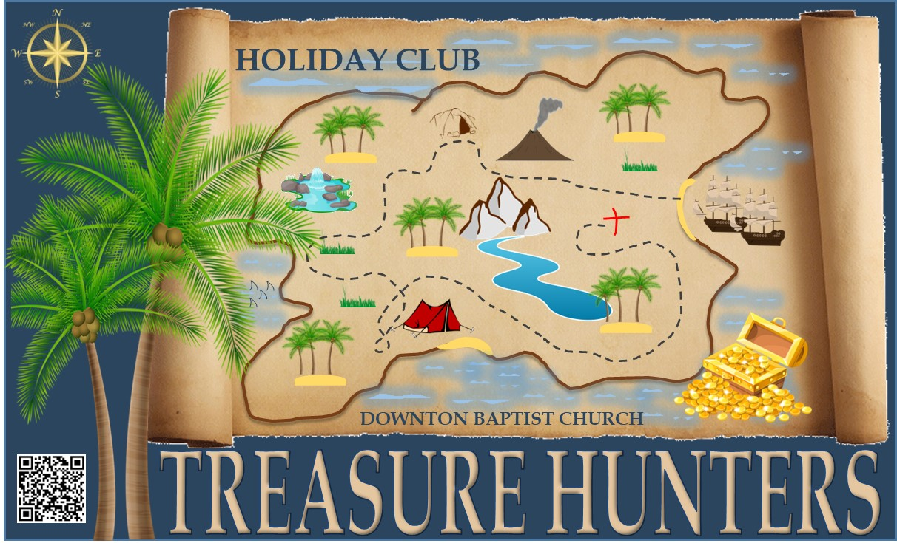
Downton Baptist Church: Keeping in touch

PRIVACY NOTICE
Under Data Protection legislation the church Charity Trustees of Downton Baptist Church are the Data Controller and can be contacted by ringing 01725 512971 or emailing office@downtonbaptist.org.
We are collecting this information to enable the church to run the Church Children and Youth groups safely and ensure we can contact you (or other nominated adult) in case of an emergency.
Data Protection legislation allows us to process this information as we regard it as being in the church’s legitimate interest. If you are unable to supply the information requested then we will be unable to accept your child at our Church groups.
The information your supply will be held in paper form in a folder which will be kept in a securely locked cupboard in the church office. Only the Ministers and the Church group leaders will have access to this information.
The forms will be destroyed once the group has finished unless you have ticked the box asking us to keep you informed about future activities we think your child might be interested in attending. If this is the case we will retain your details for the sole purpose of notifying you of such events. We will NOT pass on this information to anyone else. You have the right to ask to be removed from this circulation list at any time.
If you are concerned about the way your information is being handled please speak to our Data Protection Trustee. If you are still unhappy you have the right to complain to the Information Commissioners Office.

CHURCH EMAIL LISTS
If you would like to be included on any of the following email circulation lists please indicate overleaf
If you are happy for your details to be included please indicate where asked to do so overleaf. You can ask for all or any of your details to be removed (or amended) at any time.

SAFEGUARDING
We take our responsibilities for Safeguarding seriously and a copy of our policy is displayed in the foyer.

